New Smartphone Video Benefits Tool Makes Communicating Benefits Easy
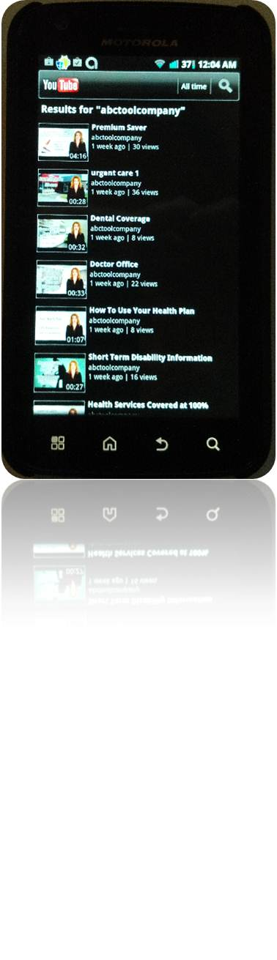

(1888PressRelease) Benefits Consulting firm launches new smartphone video benefits "app" to help Employers, HR Directors and Insurance Brokers easily explain every employee insurance benefit being offered. This service is available now and can be customized to each client's particular situation.
(1888PressRelease) Detroit, MI - Chelten Benefits Group, General Agent for numerous supplemental group Insurance carriers, today introduced a new "smartphone" based Employee Benefits Communication "app". CBG president, Dick Chelten, claims this new communications tool will help HR directors, Employees and their families and Brokers alike quickly understand every benefit being offered to them at work.
Chelten says the smartphone tool is todays' online version of an offline customized audio cassette tape communication tool he offered his clients years ago. "Back then, he says, my Benefits Agency grew from just a handful of clients to nearly 500 when I offered a complete benefits "kit" to every employee with handouts, forms, and evens pens to complete applications. Included also in each employee's kit was a customized audio cassette tape that explained all their benefits."
"Today, says Chelten, audio cassette tapes are out. Smartphones "apps" are in."
CBG now offers an online version of what they created years ago...they will put your employee benefit meetings into short video "clips", consolidate them for online viewing on the most widely viewed communication tool today...the smartphone.
For just a modest monthly subscription fee, they will customize a video benefits "app", launch it to YouTube, and maintain and monitor it for you and your client.
In fact, Chelten Benefits Group offers these customized smartphone apps FREE OF CHARGE to Agents writing other supplemental insurance products with them.
Chelten suggests interested Agents or Employers view its online sample presentation. On your smartphone, simply go to YouTube mobile app, and search for "abctoolcompany" (alternatively, from your computer, go to http://www.youtube.com/user/abctoolcompany ). YouTube will locate the customized 10 sample short video clips including "How to use your Health Plan", "Doctor's Office Visit Copays", "Urgent Care Center" and more.
For more information, contact Chelten Benefits Group at 248-464-6544 Or Email requests to Kelly ( @ ) cheltenbenefitsgroup dot com dot
www.CheltenBenefitsGroup.com
Trackback Url :
http://www.1888pressrelease.com/new-smartphone-video-benefits-tool-makes-communicating-benef-pr-389949.html
###

